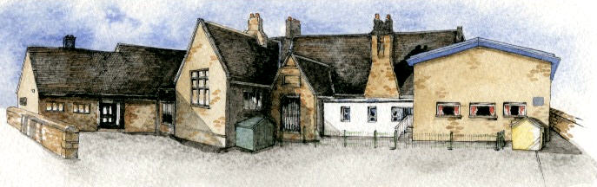
BRABIN’S ENDOWED PRIMARY SCHOOL

Brabin’s
Newsletter
28th April 2025
  Welcome to the summer term!  Let’s hope we have lots of sunshine to enjoy. Please ensure that your child has suntan lotion in school and that it is clearly labelled. Children cannot share lotion due to allergies etc.  Please check that all school uniform is clearly labelled as it is the term for losing items of clothing!  Lastly, we welcome Mr Jones who has joined us for the summer term as the Y3/4 Class teacher.    Communication  As an additional reminder, trips, residential etc. that are detailed in Parentpay will, from now, be included in the newsletter. A copy of the newsletter is also always available to view on the website.  Additionally, a text will be sent to alert any new Parentpay information.    Brockholes visit for Y1/2 and Y3/4 – 11th June 2025  The classes will be accessing different workshops during the day but will travel together on a large coach!  Y1/2 will enjoy a pond dipping and minibeasts session and Y3/4 will focus on rivers and mapskills.  Please give consent and payment via Parentpay by 4th June 2025 |  |   Class Assembly and Showcase  Parents/carers are welcome to attend their child’s class assembly and showcase. Please arrive at school for a 3.05pm start. Following the assembly, the 'Class Showcase' will take place at 3.25pm for 20 minutes. This is an opportunity to see some of the children's learning. The summer term dates are:  Reception: 11th July  Y1/2:  Y3/4: 20th June  Y5/6: Summer play – July 2025    School Residential Experiences 2026  Winmarleigh PGL Residential  March 2026  (current Y2/Y3 pupils)  A parents meeting will take place in January 2026 – we have had to book early in order to secure the booking.  In June 2026, we will be taking Y5/6 to a new centre, Wilderness Adventure at Barnard Castle. Further information to follow.    VE Day Celebrations  Thursday 8th May  The children will be learning about this important historical event and we will be having our own celebration. We ask that the children come into school on this day wearing red, white and blue clothing. | 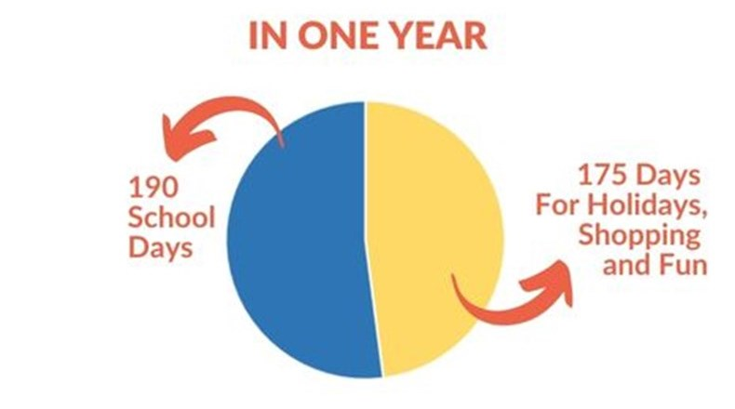 | Office Update  Dinner payments for this half term are now due:  23 days: £59.80    Family Disco - Friday 23rd May  4-6pm at Chipping Village Hall.  £10 per family payable to the office in cash please.  This is a parent supervised event and pre-school are children welcome.  Hot dogs, refreshments and glow sticks available to purchase on the day.  If anyone has any disco lights they could loan us for the party we would be really grateful.  Please contact Liz Walne or Sarah Brown.  Sponsored Fun Run on the school field - Friday 4th July from 3.30pm.  More details to follow soon.  Next Meeting - Wednesday 30th April from 3.30pm at school.  All welcome.  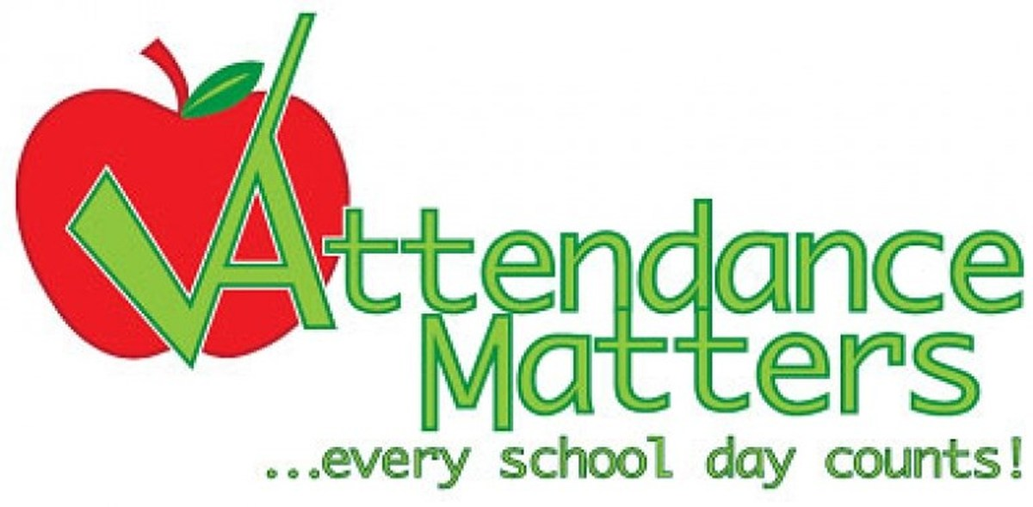  Termly attendance letters will be sent home on Tuesday 29th April.    Star of the Week  24th April  Reception: Alfie S  Y1/2: Oscar B  Y3/4: Georgie S  Y5/6: Holly H  Headteacher Award: Esme S & Arthur W  Kindness Award: Austin NW

What’s going on this half term…

SAT and test dates for Summer 2025

Y6 SAT Tests: Monday 12th May –Thursday 15th May 2025.
Y1 Phonics Screening Check: week commencing 9th June 2025
Y4 Multiplication Tables Check: week commencing Monday 2nd June 2025
Y2-Y5 end of year assessments will take place in July.
Parentpay Communication
Current Year 2 & 3 - PGL Winmarleigh Trip on 23rd & 24th March 2025
Year 5 & 6 - London on 10th & 11th July 2025

Wednesday 23rd April | Y5/6 Dermot O’Leary book launch visit
Tuesday 29th April | Tag Rugby Tournament- separate letter if selected
Wednesday 30th April | FOB meeting- all welcome – 3.30pm
Friday 2nd May | Netball Competition - separate letter if selected
Monday 5th May | May Day holiday – school closed
Wednesday 7th May | Y2 Football Tournament- separate letter if selected
Thursday 8th May | VE Day Celebration – children to wear red, white and blue clothing
Thursday 8th May & Friday 9th May | Y5 Bikeability course
Monday 12th –Thursday 15th May | Y6 SAT tests
Friday 16th May | Children around dogs workshop 2 – whole school
Wednesday 21st May | Whole School Forest School Day – more information to follow
Friday 23rd May | FOB Family Disco
MAY HALF TERM HOLIDAY:
Monday 26th May– Friday 30th May
Pupils return to school on Monday 2nd June 2025

