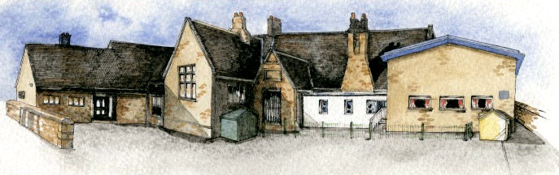

Key Learning Overview;-

Science- Children will be able to recognise how sound waves travel, explore volume changes linked to distance and how sound travels through different states.

History- the children will learn about Stone Age Britain

Art- Children will explore the work of Andy Goldsworthy, who creates natural sculpture, then create some sculptures using recycled materials.

Authentic Learning Opportunities: The children will create information videos and writings based on the stone age to share with parents in a class showcase.

Writing Opportunities- we will write: a story based on Charlotte’s Web, Non- chronological reports about the Stone Age.

**BRABIN’S ENDOWED PRIMARY SCHOOL**

**Class: Sycamore Year 3/4 Term: Autumn 1 Cycle A Curriculum Unit – Stone Age**

Class Novel, key texts and extracts-

Charlotte’s Web, Skara Brae, Wolf Brother (extracts), The Secrets of the Stone Age and The History Detectives Investigate: Stone Age to Iron Age

In KS1 children studied:

* changes within living memory. Where appropriate, these should be used to reveal aspects of change in national life (the seaside, then and now)
* events beyond living memory that are significant nationally or globally (the Great Fire of London)
* the lives of significant individuals in the past who have contributed to national and international achievements (Christopher Columbus)
* significant historical events, people and places in their own locality.

**Key Skills Coverage – History**

**Prior Knowledge**

In KS1:

* identify, name, draw and label the basic parts of the human body and say which part of the body is associated with each sense. (1-Animals including Humans)

**Prior Knowledge**

**Key Skills Coverage - Science**

**Key Vocabulary**

**Key Scientific Skills**

Pupils should be taught to:​

* identify how sounds are made, associating some of them with something vibrating
* recognise that vibrations from sounds travel through a medium to the ear
* find patterns between the pitch of a sound and features of the object that produced it
* find patterns between the volume of a sound and the strength of the vibrations that produced it
* recognise that sounds get fainter as the distance from the sound source increases.

**Sound:** vibrations that travel through the air or another medium and can be heard when they reach a person's or animal's ear.

**Source:** a place, person, or thing from which sound originates

**Vibrate:** moves rapidly to and fro.

**Vibration:** the instance of vibration.

**Travel:** make a journey between two places.

**pitch (high, low):** the frequency of the vibrations of a sound wave, leading to a high sound or low sound.

**Volume:** how loud the sign is.

**Insulation:** to protect something from sound (stop sound getting out)

In KS1 children learnt:

* to use a range of materials creatively to design and make products
* to use drawing, painting and sculpture to develop and share their ideas, experiences and imagination
* to develop a wide range of art and design techniques in using colour, pattern, texture, line, shape, form and space
* about the work of a range of artists, craft makers and designers, describing the differences and similarities between different practices and disciplines, and making links to their own work.

**Prior Knowledge**

**Key Skills Coverage -Art**

**Key Skills**

Experiment with ways in which surface detail can be added to drawings.

Use journals to collect and record visual information from different sources.

Draw for a sustained period of time at an appropriate level

**Lines and Marks**

Make marks  and lines with a wide range  of drawing implements e.g. charcoal, pencil, crayon, chalk pastels, pens etc.

Experiment with different grades of pencil and other implements to create lines and marks

**Form and Shape**

Experiment with different grades of pencil and other implements to draw different forms and shapes. 

Begin to show an awareness of objects having a third dimension.

**Tone**

Experiment with different grades of pencil and other implements to achieve variations in tone.

Apply tone in a drawing in a simple way.

**Texture**

Create textures with a wide range of drawing implements.

Apply a simple use of pattern and texture in a drawing.

**3D Sculpture**

Pupils should be taught to:

*Use recycled, natural and man-made materials to create sculptures.

*Plan, design and make models from observation or imagination.

*Use papier mache to create a simple 3D object.