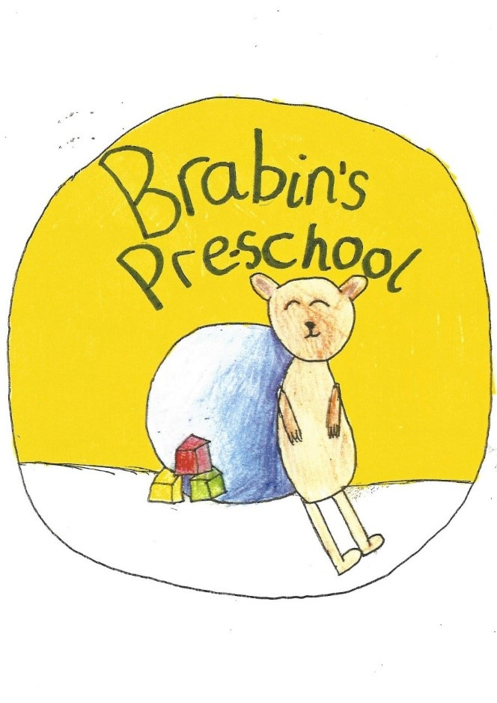
Brabin’s Pre-School
Booking Form Sept 2024

Child’s Name: _________________________________________ Child’s Date of Birth ____ / ___ / ____ Sessions required from: _____ /____ /______

Parent(s) Name: ________________________________ Parents Signature: ________________________________ Date: ____ / ____ / ____

Contact phone number: _________________________________ Contact email address: ____________________________________________________
Sessions required:
Term time only (38 weeks )

Please tick sessions which you require and we will get back to you to confirm spaces.
Session | Time | Price | Monday | Tuesday | Wednesday | Thursday | Friday
Morning session | 8:55am – 11:55am | £16.20
Lunch | 11:55am-  12:15pm | £2.60 – meal
Lunch | 11:55am-  12:15pm | £2.00 – session fee
Afternoon session | 12.15pm – 3.15pm | £16.20
School day  (excluding meal charge) | 8:55am – 3.15pm | £34.40

Prices of sessions include drinks and a snack.
Prices above for non-funded sessions (for funded child care information please visit: www.childcarechoices.gov.uk.
Prices are subject to change. Please note that regular booked sessions (including meal and session fee charges) are non-refundable in case of non-attendance. Please contact the school office for availability if you would like to book additional sessions.
When sessions are full, we operate a waiting list system on a “first come, first served” basis. You will be notified when a place is available.

