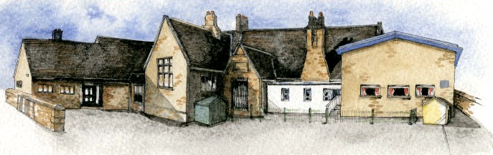

**Class Novel, key texts and extracts-**

The Owl Who Was Afraid of the Dark

Collection of books by Oliver Jeffers – Lost and Found, Here We Are, Up and Away, Stuck etc

Books and internet pages about animals and the hot and cold places of the world.

**Key Learning Overview;-**

**Science**- Children will **i**dentify and name a variety of common animals including fish, amphibians, reptiles, birds and mammals. They will describe and compare the structure of a variety of common animals.

**Geography-** Children will learn about the seven continents of the world. They will use globes and atlases to locate the hot and cold places of the world (the Polar Regions and countries along the equator). They will also learn the names of the different animals found in these places.

**Art-** Children will make observational drawings of penguins from images. They will use their drawings as inspiration to create digital images.



Class: Elm Class Year 1/2 Term: Autumn 1

**Curriculum Unit – The Hot and Cold Places of the World**

**Writing Opportunities**-

We will write:

* character profiles and our own story based on the book Lost and Found by Oliver Jeffers
* letters from one character to another
* non-chronological reports of animals

Be Curious: Develop an appreciation of and responsibility for the environment. Experience contrasts (polluted/unspoilt, light/dark, hot/cold)

Be Knowledgeable: Develop subject specific vocabulary. Make the links between the work in science and geography, looking at animals and where they live.

Be Adventurous: Work practically

Be Ambitious: Develop responsibility for one’s own learning

Be Creative: Apply new skills to new situations. Ask questions to find out about the different countries being studied?

Be Collaborative: Work as a team using maps and globes to locate the continents of the world

Be Reflective: Identify and use one's aptitudes and interests as a vehicle for learning

Be Positive:

* What do we mean by the hot/cold places of the world?
* Where are the hot/cold places in the world located?
* What is the weather like in the hot places of the world (near the Equator)?
* What is the weather like near the cold places of the world (North or South Pole)?
* How is the weather at the Equator/Poles different from the weather in our country?
* What are some of the most common animal classes?
* What do animals eat?
* What sorts of animals live in that hot/cold place?
* What sorts of plants grow in that hot/cold place?
* What would it be like to live in that hot/cold place?

**Curriculum Shapers**

**Key Questions**

**Key Skills Coverage – Science**

**Prior Knowledge**

**EYFS –**

Children know about similarities and differences in relation to places, objects, materials and living things. They talk about the features of their own immediate environment and how environments might vary from one another. They make observations of animals and plants and explain why some things occur and talk about changes. (Early Learning Goal)

**Year 2 Children**

*Observed and collected information about the seasonal changes to the weather.

**Key Vocabulary**

**Key Skills and Knowledge**

**Animals** – a living thing that needs water and food to survive and is not a plant.

**Mammals** - a warm-blooded animal (as a dog, mouse, bear, whale, or human being) with a backbone that feeds its young with milk produced by the mother and has skin usually more or less covered with hair

**Fish** - A **fish** is an animal which lives and breathes in water. All **fish** are vertebrates (have a backbone) and most breathe through gills and have fins and scales

**Birds** - **Birds** are a class of vertebrates. They are warm-blooded and lay eggs. Their bodies are covered with feathers and they have wings

**Reptiles** - a cold-blooded animal (as a snake, lizard, turtle, or alligator) that breathes air and usually has the skin covered with scales or bony plates

**Amphibians** - any of a group of cold-blooded vertebrate animals (as frogs and toads) that have gills and live in water as larvae but breathe air as adults

**Carnivores** – animals that eat meat (other animals)

**Herbivores** – animals that have a plant based diet

**Omnivores** – animals that eat both plants and meat

**Vertebrates** - an animal with a backbone

**Invertebrates** – an animal without a backbone

**Working Scientifically**

Identifying and classifying

|  |  |
| --- | --- |
| *Children use their observations to compare living things.  They sort and group these things, identifying their own   |  | | --- | | criteria for sorting.  *They use simple secondary sources (such as identification  sheets) to name living things. They describe the  characteristics they used to identify a living thing. | |

**Knowledge**

*Identify and name a variety of common animals including fish, amphibians, reptiles, birds and mammals.

*Identify and name a variety of common animals that are carnivores, herbivores and omnivores.

*Describe and compare the structure of a variety of common animals (fish, amphibians, reptiles, birds and mammals, including pets).

**Key Skills Coverage – Geography**

**Prior Knowledge**

**EYFS - Understanding the world: The world**

*Looks closely at similarities, differences, patterns and change during their Forest Schools work

*Children know about similarities and differences in relation to places and living things.

**Year 2**

*Used globes, maps and atlases to locate the UK and named the four countries and capital cities of the UK

*They learnt about the human and physical features of the UK

* For World Geography Day they located and researched Peru

**Key Vocabulary**

**Key Skills and Knowledge**

**Place Knowledge**

*Name and locate the world’s seven continents and five

oceans.

**Human and Physical Geography**

Use basic geographical vocabulary to refer to the key human and physical features of the Polar Regions and countries along the equator.

**Mapping**

*Use a range of maps and globes (including picture maps) at different scales.

*Know that maps give information about places in the world (where/what?).

*Locate land and sea on maps.

**Enquiry and Investigation**

*Ask simple geographical, ‘where?’, ‘what?’, and ‘who?’ questions about the world and their environment e.g. ‘What is it like to live in this place?’

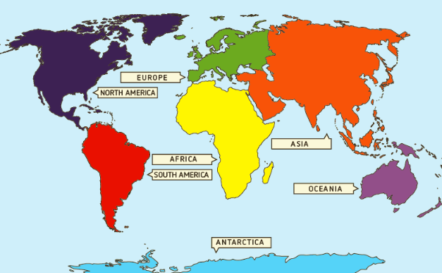

|  |  |
| --- | --- |
| **Equator** | An imaginary line drawn around the centre of the Earth that is halfway between the North and South poles |
| **Arctic Circle** | An imaginary line drawn on the globe. Is the most northern line on the globe. |
| **Antarctica** | The coldest place on Earth. |
| **North Pole** | The northern most point on the Earth. |
| **South Pole** | The Southern most point on the Earth. |
| **habitat** | The natural home or environment of a plant or animal. |
| **adapt** | To become adjusted to new conditions (for example a change in weather or environment). |
| **Weather** | The state of the atmosphere (whether it is hot, cold, sunny, raining etc.) |
| **desert** | A waterless area of land with little to no vegetation (plants) |
| **Arctic Ocean** | The worlds coldest ocean that is also the smallest and shallowest of the worlds 5 major oceans. |
| **Southern Ocean** | Surrounds Antarctica and is the worlds southernmost ocean. |
| **Continent** | A large land mass which many countries are part of. There are seven continents on Earth. |

**Key Skills Coverage – Art**

**Prior Knowledge**

**All children**

*portraits with a focus on line and shape

**Year 2 –**

*explored mark making with charcoal and chalk

*explored the human figure using pencil and oil pastel

**Key Vocabulary**

**Key Skills and Knowledge**

**Digital art - Digital art** is work made with **digital** technology or presented on **digital** technology. This includes images done completely on computer or hand-drawn images scanned into a computer and finished using a software program like Adobe Illustrator

**Texture -** how something feels when it is touched, is an important part of art. **Texture** can be actual, or tactile, which **means** it can really be felt; or it can be implied or visual **texture**, which just looks as if there are **textures** on a surface that's really smooth to the touch.

**Graphics -** a pictorial image or series of images displayed on a computer screen

**Fill –** a tool thatfloods an area with colour

**Eraser –** a tool used to rub out on screen

**Cropping –** taking away unwanted parts of an image

**Drawing**

Experiment with a variety of media; pencils, rubbers, crayons, pastels, felt tips, charcoal, ballpoints, chalk.

Control the types of marks made with the range of media.

**Form and Shape**

Observe and draw shapes from observations.

**Digital Media**

*Explore ideas using digital sources

*Use a simple graphics package to create images and effects with:

**Lines**

**\***by changing the size of brushes in response to ideas;

**Shapes**

*using eraser, shape and fill tools; and

**Colours and texture**

*using simple filters to manipulate and create images.

Use basic selection and cropping tools.