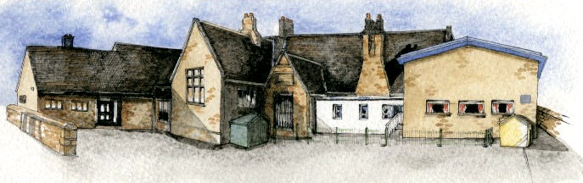

**Writing Opportunities**-

The children will write:

* Recipes for their healthy snack from the previous unit
* Recounts
* Poems with a structure (Limericks/Riddles)
* Information about old and new toys

**Key Learning Overview;-**

**Science –** The children will identify a variety of everyday materials. They will compare and group together the materials on the basis of their simple physical properties and their uses.

**DT –** The children willbegin tobuild structures with some independence exploring how they can be made stronger, stiffer and more stable.

**History -** The children will investigate old and new toys and explore the materials that were used to create them. They will further develop their understanding of chronology by arranging groups of toys from oldest to most modern.



Class: Elm Class Year 1/2 Term: Summer Term

**Curriculum Unit – The World of Materials**

**Class Novel, key texts and extracts-**

The Velveteen Rabbit

Traction Man

That Rabbit Belongs to Emily Brown

Recipes

Limericks & Riddles

Lost in the Toy Museum

Information books about Old and New Toys

* Be Curious: Show an interest in life in the past.

*Use a range of sources to ask and answer questions

* Be Knowledgeable: Receive, record and apply information to new situations, using knowledge of materials to support work in history *Nurture a thirst for knowledge
* Be Adventurous: Experience exhilaration, challenge and achievement
* Be Ambitious: Strive for improvement to build a more stable and secure structure
* Be Creative: Apply skills to new situations
* Explore alternatives in problem solving situations
* Be Collaborative: Work with others in an interactive learning process

* What are materials?
* How can you change a material?
* What materials can you not change?
* How can you make a structure more stable?
* What is the best method to join parts in a structure?
* What are toys made from?
* What toys did my grandparents play with?
* What toys did my parents play with?
* How are the toys my parents/grandparents different to the toys I have today?
* What toy did they have in Victorian times?
* Why are they different?

**Curriculum Shapers**

**Key Questions**

**Key Skills Coverage – Science**

**Prior Knowledge**

**EYFS –**

*Children know about similarities and differences in relation to places, objects, materials and living things. They talk about the features of their own immediate environment and how environments might vary from one another. They make observations of animals and plants and explain why some things occur and talk about changes.

**Year 2 Children**

* Identify and compare the suitability of a variety of everyday materials, including wood, metal, plastic, glass, brick, rock, paper and cardboard for particular uses.

*Find out how the shapes of solid objects made from some materials can be changed by squashing, bending, twisting and stretching.

**Key Skills and Knowledge Key Vocabulary**

**Material -** the **matter or substance that objects are made from**

**Names of materials** **–** wood, metal, plastic, glass, brick, rock, paper, cardboard

**Properties of materials** – hard, soft, stretchy, stiff, bendy, floppy, waterproof, absorbent, breaks/tears, rough, smooth, shiny, dull, see-through, not see-through

**Working Scientifically**

*Classify objects made of one material in different ways e.g. a group of object made of metal.

*Classify in different ways one type of object made from a range of materials e.g. a collection of spoons made of different materials.

*Classify materials based on their properties.

*Test the properties of objects e.g. absorbency of cloths, strength of party hats made of different papers, stiffness of paper plates, waterproofness of shelters.

**\*Plan:** *Set up enquiry*

Materials floating and sinking (Y1)

**Scientific Knowledge**

*Distinguish between an object and the material from which it is made.

*Identify and name a variety of everyday materials, including wood, plastic, glass, metal, water, and rock.

*Describe the simple physical properties of a variety of everyday materials.

*Compare and group together a variety of everyday materials on the basis of their simple physical properties.

**Key Learning**

*All objects are made of one or more materials. Some objects can be made from different materials e.g. plastic, metal or wooden spoons.

*Materials can be described by their properties e.g. shiny, stretchy, rough etc. Some materials e.g. plastic can be in different forms with very different properties.

**Key Skills Coverage – DT**

**Prior Knowledge**

**EYFS – Expressive Arts: Exploring and using media and materials**

* Children safely use and explore a variety of materials, tools and techniques, experimenting with colour, design, texture, form and function.

**EYFS – Expressive Arts: Being imaginative**

*Children use what they have learnt about media and materials in original ways, thinking about uses and purposes. They represent their own ideas, thoughts and feelings through design and technology.

**Key Skills and Knowledge Key Knowledge**

**structure -** something built or arranged in a definite way

**join –** to fasten together

**framework –** a structure that supports something built on or around it.

**weak -** likely to break or fail under strain or pressure; not sturdy

**strong -** not easy to break or harm

**stiffer -** not as easy to bend

**stable -** fixed, firm, or steady in position; not shaky or easily moved

**base –** the bottom of the structure; that on which something stands or rests; foundation

**hacksaw -** a saw used to cut wood, with a tough, fine-toothed, short blade fixed in a frame

**bench hook –** a workbench appliance used in woodworking to hold wood in place while cutting with a hand saw

**dowel -** a narrow round wooden rod

**Design - generating ideas**

*Select appropriate techniques explaining first/next and last.

*Draw a labelled picture of their product, which may include parts, components and materials to describe their idea.

**Making**

*Explore how to make structures stronger.

*Join appropriately different materials.

*Test different methods to ensure the structures are stable.

*Cut dowel using a hacksaw and bench hook.

*Use a glue gun with supervision.

**Evaluating**

*Describe anything that didn’t work as well and any changes they had to make.

*Suggest how their product could be improved.

**Technical Knowledge**

*Build structures, exploring how they can be made stronger, stiffer and more stable

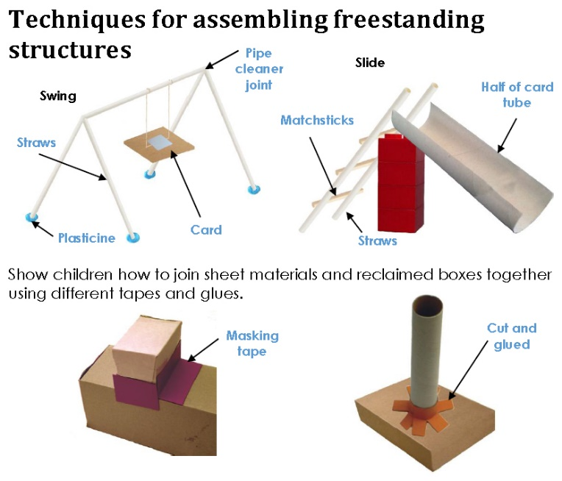

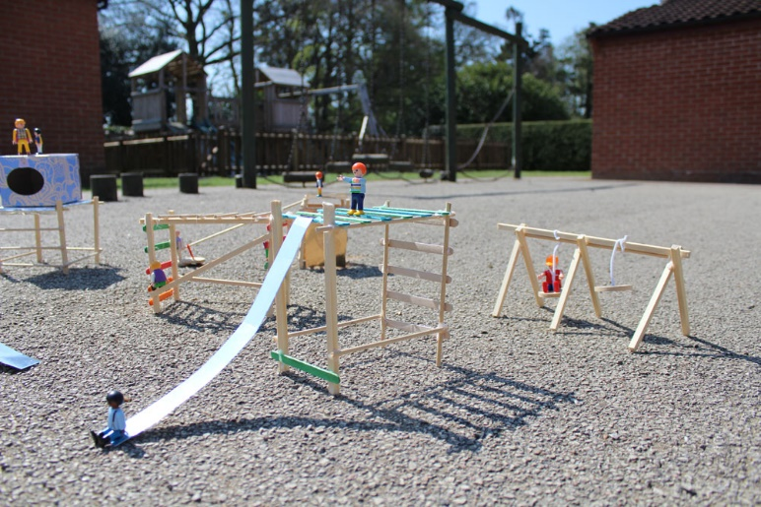

**Key Skills Coverage – History**

**Prior Knowledge**

**EYFS – Understanding the world: The world**

*Children know about similarities and differences in relation to places, objects, materials and living things. They talk about the features of their own immediate environment and how environments might vary from one another. They make observations of animals and plants and explain why some things occur, and talk about changes.

**KS1**

*During the Me, My Family and My Friends topic the children found out about Queen Victoria

*They gained an understanding of chronology and explored how their lives were different and similar to the lives of people in the past

**Key Skills and Knowledge Key Knowledge**

**toy** **–** any object that can be used in play, especially by children

**materials** **–** what the toys are made of

**new –** having recently been produced

**modern -** of or having to do with the latest styles or ideas

**ancient –** very old; existing for many years; of or relating to times long ago

**Victorian toy –** a toy popular or around during Victorian times

**mechanical toy –** toyspowered by mechanical energy. Depending on the mechanism used they can perform a range of motions, from simple to very complex

**Stieff bear –** oldest and most well-known teddy bear

**Theodore Teddy Roosevelt –** US President who the teddy bear is named after

**Chronology**

* Order and sequence some familiar objects.

*Identify some similarities and differences between ways of life at different times.

*Recognise that their own lives are similar and / or different from the lives of people in the past.

*Use common words and phrases concerned with the passing of time.

**Events, People and Changes**

* Describe some changes within their living memory

**Enquiry**

*Observe small details and handle a range of sources – such as pictures, written sources

*Ask and answer simple questions about the past through observing and handling a range of sources.

*Consider why things may change over time.

*Use sources to answer simple questions about the past.

**Stieff bear**

