BRABIN’S ENDOWED PRIMARY SCHOOL  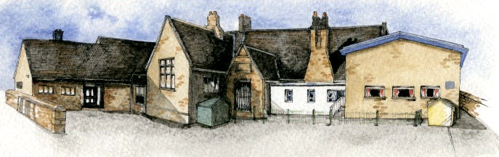 | French Curriculum Overview year A 2023-24

Rec | Autumn 1 | Autumn 2 | Spring 1 | Spring 2 | Summer 1 | Summer 2
 | Introductions  greetings | How are you? | Numbers | colours | Parts of the body | snails
Year 1/2 | My family | My pets | Fruit  Descriptions  Likes and dislikes | Numbers  1-20 in and out of sequence | 4 food shops | Buying food in the shops
Year 3/4 | Playground rhymes and songs | Playground games | Months and numbers 1-31 | Celebrations | Portraits | ‘The Four Friends’ story
Year 5/6 | Planets – factual writing | Imaginative writing about planets | Places in the school | What we do at school | The café and Euros | Quantities of food and opinions

